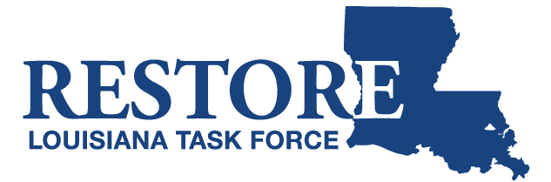

NOTICE OF PUBLIC MEETING
Restore Louisiana Task Force

The meeting of the Restore Louisiana Task Force
has been scheduled for:

Friday, October 27, 2017
9:30 am
City of Covington Council Chambers
222 E. Kirkland Street
Covington, Louisiana 70433

If you need further information, please call
Lori Dupont (225) 342-1626

